TABLE OF CONTENTS

- Purpose of a Disaster Plan ................................................... page 1
- Governance .......................................................................... page 1
- Plan Review, Dissemination, and Development ................. page 1
- Disaster Plan Responsibility Assignments .......................... page 2
- Asset Identification .............................................................. page 3
- Salvage Priorities ….............................................................. page 4
- Risk Identification …............................................................ page 5
- Risk Mitigation Strategies (Ongoing & Pre-Disaster)
A. High Winds ............................................................ page 6
B. Tornado or Severe Thunderstorm …...................... page 7
C. Drought …............................................................... page 8
D. Loss of Irrigation …................................................ page 9
E. Fire …...................................................................... page 10
F. Ice Storm, Snow Storm, Temperature Swings....... page 11
G. Failure of Automated Controls ….......................... page 12
H. Loss of Rare Plants or Plant Records .................... page 13
I. Information Technology (IT) Hazards ……............. page 14
J. Bomb Threat …........................................................ page 15
K. Active Shooter ……………………………………………….. page 16
- Post-Disaster Reaction, Recovery, and Evaluation …......... page 17
- Appendices
Appendix 1: LGBG/LGNR Internal Communication List
Appendix 2: LGBG All Staff Contact List
Appendix 3: LGBG Alarms and Utilities Map
Appendix 4: LGNR Irrigation Map
Appendix 5: LGBG Network Diagram
Appendix 6: LGBG Physical and Virtual Server List
Appendix 7: Living Collections Contractors/Vendors
Appendix 8: Living Collections Post-Disaster Resources
Appendix 9: Non-Living Collections Contractors/Vendors
Appendix 10: Non-Living Collections Post-Disaster Resources
Appendix 11: Facilities Contractors/Vendors
Appendix 12: IT Contractors/Vendors
Appendix 13: Disaster Impact Report Form
Appendix 14: Bomb Threat Procedures and Checklist
Appendix 15: Active Shooter Pocket Card

I. Purpose of a Disaster Plan
The purpose of a Disaster Plan is to organize, clarify, and disseminate information and procedures that serve to protect the Living Collections, Non-Living Collections and other assets and resources at Lewis Ginter Botanical Garden (hereafter the Garden) and Lewis Ginter Nature Reserve (hereafter the Reserve) in the event of a disaster event.

II. Governance
The Disaster Plan is approved by the President and Chief Executive Officer and the Board of Directors. The Chief Operating Officer, Director of Horticulture, Director of Facilities, Director of Education and Exhibitions, at the direction of the President and CEO, shall be responsible for implementing this policy. He/she may utilize the Horticulture, Operations, and/or Security staff, other staff members, and various experts as appropriate.

III. Plan Review, Dissemination, and Development
- Review Schedule
  - Annual contact information review. The Plant Records Curator will conduct an annual review of the contact list and make any changes to those lists as necessary.
  - Bi-annual comprehensive plan review. The Plant Records Curator will initiate a comprehensive bi-annual review of all processes and procedures in collaboration with Chief Operating Officer, Director of Horticulture, Director of Facilities, and Director of Education and Exhibitions. This process will begin in January of even-numbered years and will be routed to the Horticulture, Educations and Exhibitions (HEE) committee in March of that same year. The HEE committee will report policy revision and renewal to Board of Directors.
  - Biannual reviews should include:
    - Inviting local emergency responders and/or horticultural contacts to “walk through” the areas
    - A test of the plan and adjustments of any identified weaknesses
    - Evaluation of any actual disaster event responses
- Dissemination Guidelines
  - The Disaster Plan will be saved in the Shared Drive and posted on the Staff Dash.
  - After each update, a PDF copy of the updated plan will be made available to all staff through the Staff Dash, and Shared Drive.
  - Managers should Share with new hires during on-boarding.
  - Review with all staff annually, or more often, as appropriate.
- Plan Development Strategies
  - Investigate agreements with local, regional, and out-of-region organizations and businesses that could help the Garden and Reserve prepare or recover if necessary.
  - Initiate relationships with local university extension offices and county agencies to find regional disaster research and planning materials for horticulture/arboriculture.

IV. Disaster Plan Responsibility Assignments

The following abbreviations will be used for the remainder of this document:
LGBG | Lewis Ginter Botanical Garden | DoEE | Director of Education and Exhibitions
LGNR | Lewis Ginter Nature Reserve | LAM | Library and Archives Manager
P&CEO | President & Chief Executive Officer | FR | Facility Rentals
COO | Chief Operating Officer | RAD | Restaurant Associates Director
FC | Finance Comptroller | MoV | Manager of Volunteers
DoPRM | Director of PR & Marketing | Hort | Horticulture Staff
DoH | Director of Horticulture | Ops | Operations & Facilities Staff
DoF | Director of Facilities | EE | Education & Exhibitions Staff
IT | Information Technology | IC | Incident Commander
LC | Living Collections | NLC | Non-Living Collections
NOTE: If any staff member is unable to fulfill their disaster plan responsibility assignments, their acting replacement or designee will be charged with the task(s) at hand.

Pre-Disaster:
- COO notifies CEO, DoH, DoF, and RAD of potential disaster threat and timeline.
- COO, with support from DoH, DoF, and RAD, activates preparation plans for disaster.
- DoH and DoF are responsible for safeguarding highest priorities.

Post-Disaster:
- DoH and DoF are responsible for safeguarding highest priorities. DoH, DoF, or designee(s) will be the first person back on scene following a disaster to assume the role of Incident Commander (IC) and is to remains in that role until relieved by a person in higher authority (if necessary).
- The IC will carry out the following, keeping human safety and security paramount and adhering to the detailed Reaction, Recovery and Evaluation Protocols listed in Section IX.
  - Participate in, delegate and assign property-wide conditions assessment, including safety hazards and property damages
  - Communicate above assessments to P&CEO, FC, D0PRM
  - Establish communication needs with FC to relay to insurance company
  - Coordinate internal and public messaging requirements (DoPRM)
  - When possible to do so safely, prioritize recovery plans and coordinate clean-up efforts
- DoH and/or LGBG Horticulturists will assess the LGBG living collections as assigned.
- DoH and/or LGNR Gardeners will assess the LGNR living collections as assigned.
- DoF will assess LGBG structures and facilities and/or assigned as needed.
- LAM will assess LGBG non-living collections as assigned.
- Mindful of Identified Assets (Section V.) and detailed Salvage Priorities (Section VI.), salvage efforts for LC, NLC, IT and Facilities assets will be prioritized as follows:
Level 1: highest priority; inspect/recover 1st, as soon as it is safe to do so
Level 2: inspect/recover 2nd, after Level 1 assets are secure and it is safe
Level 3: inspect/recover 3rd, after Level 1 and Level 2 assets are secure and it is safe
Level 4: inspect/recover 4th, after Level 1 – Level 3 assets are secure and it is safe
Level 5: lowest priority; inspect or recover last

V. Asset Identification

- Living Collections: Items of high value or worth
- Conservatory collections (orchids, palms, bromeliads, aroids, cacti & succulents)
- Orchid collection (greenhouse and Conservatory)
- Rhododendron (LGBG, LGNR)
- Magnolia (LGBG, LGNR, greenhouse)
- Sarracenia (LGBG West Island)
- Legacy trees (pending; a complete list of Legacy Trees is currently being researched)

- Non-Living Collections: Items of high value or worth
- Descubes Botanical Illustration Collection (4 cabinets, main archive room)
- Lee Park/Bessie Marshall Watercolor Collection (boxed & framed, herbarium room)
- Lewis Ginter’s passport and prayer book (main archive room)
- Reichenbachia Chromolithographs (two cabinets, main archive room)
- Rare book collection (three book cases in main archive room)

- Facilities: Assets of high value or worth
- Historic structures with intrinsic value due to their irreplaceability (Bloemendaal House, Carriage House and, to a lesser extent, Locbury House)
- Structures that serve to protect valuable or important collections or assets (Kelly Education Center, Robins Visitor Center, Conservatory and greenhouse).
- Institutional hard-copy records essential to continuity of operations (payroll and personnel files in Lakeside House, Advancement files from Bloemendaal House).
- Equipment that is either remarkably difficult or costly to replace (Matica C330 embossing machine in Plant Records Office, lower level of the KEC)

VI. Salvage Priorities

- Living Collections: Salvage Priority Levels
Level 1
- Federally listed species, state listed species, candidates for listing
- Rare plants from extirpated populations
Level 2
- Rare plants (Chris Migliaccio & Mt. Holyoke College Botanic Gardens donations)
- Rare cultivars
- Unique hybrids (Bill Smith magnolia hybrids)
- Plants from the plant taxa of focus, as identified by the Living Collections Policy
- Charismatic focal plants
Level 3
- Accessioned specimens and labeled specimens
- Plants of known provenance not listed above (JC Raulston Arboretum)
Level 4
- Specimens that will not be accessioned, per the Living Collections Policy (annuals, etc.)
- Plants in unmaintained areas or plants of unknown provenance

- Non-Living Collections: Salvage Priority Levels
The Kelly Education Center has three spaces within the basement that house archival, object and rare book collections. Some items in the collection are unique and, thus, irreplaceable. In general, recovery priorities for collections follow the priority structure below.
Level 1 – Closest
Level 2 – Most valuable
Level 3 – Most vulnerable
Level 4 – Least damaged
Level 5 – Most damaged
If recovery efforts are limited, recovery will focus on the Items of High Value or Worth (Section V.)

- Facilities: Salvage Priority Levels
Level 1 – Safety
Level 2 – MEP Assessment and recovery
Level 3 – Building recovery priority (see Section V. Asset Identification)
Level 4 – Employee work space assessment and prioritization
Level 5 – Temporary office plan

- IT: Salvage Priority Levels
Level 1 – Critical servers (domain controllers, point of sales server & workstations)
Level 2 – Secondary Servers
- Databases, including: finance, advancement, horticulture, irrigation server, greenhouse temperature system, PlantsPlus
- Wireless devices
Level 3 - Individual workstations, peripherals, including: wireless devices, printers and MFDs

VII. Risk Identification

These hazards are identified as possible threats to the Garden’s and Reserve’s people, assets, and collections:

- High winds
- Tornado or severe thunderstorm
- Drought
- Loss of irrigation
- Fire
- Ice storm, snow storm, or extreme temperature swings
- Failure of automated climate controls in glass houses
- Loss of rare plants or plant records
- IT Hazards
- Cyberattack/ransomware
- Power outage – short term/long term
- Computer viruses and malware
- Hardware/server failure

- Bomb threat
- Active shooter

VIII. Risk Mitigation Strategies

On the following pages, mitigation strategies (both ongoing and in the face of imminent event) are detailed for each of the hazards, disasters, or emergencies listed previously.

- Risk Mitigation Strategies – High Winds

High winds are defined by the National Weather Service as sustained winds of 31-39 mph for an hour or more and/or wind gusts of 46-57mph for any duration.

In case of imminent high winds, when directed by COO, staff will take the following actions:
- Turn over benches (Hort)
- Secure plants 1-gallon or smaller by moving indoors or clustering (Hort)
- Secure large potted plants by clustering, staking or moving indoors (Hort)
- Check events calendar; cancel events as needed (FR, E&E)
- Drop or break down tents (Ops)
- Greenhouse and Conservatory doors and vents set to manual-shut (Hort)

- Risk Mitigation Strategies – Tornado or Severe Thunderstorm

A tornado is defined by the National Weather Service as “a violently rotating column of air touching the ground, usually attached to the base of a thunderstorm.” During tornadoes, staff can expect winds reaching a speed of 300 miles per hour, strong downburst winds, hail, and debris.

During severe thunderstorms, staff and visitors should be moved inside to prepare for worsening conditions and should avoid windows and glass surfaces and take refuge in doorways, under desks, tables or other barriers.

During tornado watches, staff, visitors, and rental event attendees should be brought inside to prepare for escalating conditions.

During tornado warnings, all staff, guests, and event attendees should be moved to one of the following basements, depending on their location: RVC, KEC, Conservatory, Locbury House, Woodman Road House, Bloemendaal House and Carriage House.

In case of imminent tornado or severe thunderstorm, when directed by COO, staff will take the following actions:
- Turn over benches (Hort)
- Secure plants 1-gallon or smaller by moving indoors or clustering (Hort)
- Secure large potted plants by clustering, staking or moving indoors (Hort)
- Check events calendar; cancel events as needed (FR, E&E)
- Drop or break down tents (Ops)
- Set Greenhouse and Conservatory doors and vents to manual-shut (Hort)
- Cut power to systems that may be damaged by lightning strike (Ops)
- Power off computers (all staff)
- Prepare, gas up, and centrally stage cleanup equipment, i.e. chainsaws, leafblowers, etc. (Hort)
- Sweep the Garden grounds and buildings, warning staff and guests of danger and encouraging them to seek shelter immediately (all staff)

- Risk Mitigation Strategies – Drought

Primary source for current drought status is Virginia DEQ Office of Water Supply Drought | Virginia DEQ (updated hourly, focuses on hydrological drought in a water year; image below, left).

Additional source for drought status is the NOAA Drought Monitor Data Snapshot Drought Monitor | NOAA Climate.gov (updated weekly, focuses on shorter-term metrics; image below, right).

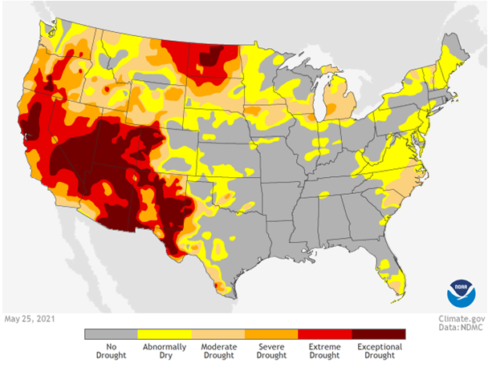
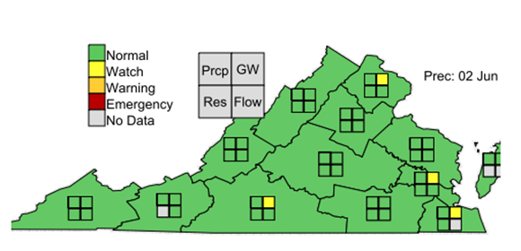

Ongoing drought stress mitigation strategies:

- Maintain mulch around plantings and trees (Hort)
- Maintain 10 yards of mulch on-hand to use as needed to minimize drought stress (Hort)
- Reduce soil compaction damage by limiting access of any heavy machinery (Hort, Ops)
- Regularly monitor levels of irrigation lake (Hort)
- Check irrigation pump preventative maintenance and operability (Hort, Ops)
- Maintain irrigation systems (Hort)
- Maintain irrigation lakes (Hort)

In case of severe drought, when directed by COO, staff will take the following actions:

- Ensure 10 yards of mulch are onsite, to use as needed (Hort)
- Increase frequency of field inspection for stressed plants (Hort)
- Install water bags to high-value trees (Hort)
- Increase frequency of monitoring of irrigation lake levels; if more water is needed, it can be acquired either by renting a meter with the Henrico County Department of Public Utilities or by contracting a water truck from a private vendor (Hort). See appendix for vendors.

- Risk Mitigation Strategies – Loss of Irrigation

In case of loss of irrigation or failure of impoundment, due to mechanical breakdown in the irrigation lake pump house or failure of the berms or impoundment around the irrigation lakes, when directed by the COO, staff will take the following actions:

- If an irrigation lake berm failed, call Virginia Department of Conservation and Recreation, Division of Dam Safety and Floodplain Management 804.371.6095 to report the failure.
- If the pump from the irrigation lakes failed, call Pro Pump & Controls to contract repairs.
- If the irrigation lines are broken, call Montgomery Irrigation to contract repairs.
- To refill water in the irrigation lakes, the Garden can rent a water meter from Henrico County or secure a water tanker truck from a private vendor. See Appendix X: Living Collections Vendors.
- In the case of extended inability to irrigate gardens, see Drought Stress Mitigation Strategies on previous page.

In case of loss of irrigation ability in the Conservatory or Greenhouse, due to an issue with the public water supply that feeds those structures, DoH or DoF will take the following actions:

- Call the Henrico County Department of Public Utilities 804.501.4275 to secure repairs.
- Inform the DoF and/or COO, as needed.

- Risk Mitigation Strategies – Fire

Ongoing fire mitigation strategies:

- Review location of fire extinguishers in every building (DoF)
- Ensure fire suppression systems and fire extinguishers are maintained (DoF)
- Be prepared to call 911 for the Henrico County Division of Fire (LGBG) or Goochland County Fire-Rescue and Emergency Services (LGNR)

In case of fire emergency, staff will take the following actions:

- If a small, localized fire, attempt to extinguish it with the nearest fire extinguisher; notify COO and DoF, then follow incident reporting protocol.

- If NOT a small, localized fire, call 911 immediately
- Pull nearest fire alarm
- Evacuate the building(s)
- Inform staff via radio Channel 1, 2, and 3, declare the emergency, and direct all staff to go to Channel 1 until the emergency is over
- As needed, guide emergency responders to the building(s) of concern

- Risk Mitigation Strategies – Ice Storm, Snow Storm, Fluctuating Temperatures

In the case of imminent ice storm, snow storm or extreme temperature swings, (freezing temps to mid-70F in 24 hours), staff should take the following actions:

- Apply additional mulch to marginal or recently-installed plants (Hort)
- Use floating row covers to protect exposed containers in nursery (Hort)
- Check automated climate control sensors, settings, operability (Hort, Ops)
- Use irrigation and hose bib cut-offs to prevent pipe damage (Hort, Ops)
- Notify staff if any interior facility faucets need to be left dripping, especially in the older structures (DoF)
- Greenhouse and Conservatory doors and vents set to manual-shut, if appropriate (Hort)
- Prepare, gas up, and centrally stage cleanup equipment, i.e. chainsaws, leafblowers, etc. (Hort)
- Prepare buckets of salt/sand and stage in the KEC Prep Room (Ops)
- Stage any necessary spreading tools or equipment in the KEC Prep Room (Ops)
- Stage snow shovels and other snow-clearing tools in the KEC Prep Room (Ops/Hort)

- Risk Mitigation Strategies – Failure of Automated Controls

Ongoing mitigation strategies to prevent failure of automated controls in Greenhouse and Conservatory:

- Ensure routine Preventative Maintenance (PM) of Greenhouse and Conservatory (Hort, Ops)
- Visually inspect components, glass, motors, shadecloths, pumps, etc. routinely (Hort)
- Report any structural or mechanical defects to DoH and DoF as soon as possible (Hort)
- Ensure maintenance tickets are addressed in a timely manner (Ops)

In the case of imminent disaster or weather events, staff should:
- Inspect component operability and create maintenance tickets as needed (Horts)
- Use manual controls as necessary to mitigate any plant damage, i.e., manually shut all vents when there’s a pending hurricane (Horts)

- Risk Mitigation Strategies – Loss of Rare Plants or Plant Records

Ongoing mitigation strategies to preserve rare plant material and protect plant records:

- Create redundant backups of rare plants by propagating rare plants in the Living Collection (esp. plants that are listed, rare, unique, and/or an accessioned plant of interest).
- Locate such propagated plants in multiple locations (i.e. another property, garden, or private residence).
- Ensure records of rare plant propagation and multi-site redundancy records are delivered to Plant Records Curator.

Pending mitigation strategies to preserve plant records:

- Accessions are redundantly labeled using more than one method (accession number marked on tag in pot or buried in ground, accession number on metal accession tag on plant or in pot, and/or accession number marked on display label when appropriate).
- Centralize LGNR plant records with LGBG records in IrisBG. Currently, records on newly-acquired plant material are still maintained on the outdated PlantsPlus software onsite at the Reserve. The most recent backup was in April 2019. A current 2021 backup should be and future acquisitions should be routed through the Plant Records Curator.

I. Risk Mitigation Strategies – Information Technology Compromise

Ongoing IT security and mitigation strategies:

- The Garden employs a three-layer backup strategy:
  - On-site Backups: the Microsoft System Center Data Protection Manager (DPM) runs on a 4-hour cycle for replication with a one month retention (based on storage).
  - Off-site backups: using iBackup, a backup is stored in a remote location in the Cloud.
  - On-premise imaging: a tool called Macrium Reflect provides a snapshot of each server in order for quicker restore.
- Data center security: the Garden’s server room/data center is located in a secure room with limited access. Climate in the data center is managed with an independent AC unit that controls temperature and humidity.
- Vigilant anti-virus protection: the Garden maintains ESET anti-virus and anti-spyware protection on all workstations and servers. Updates are deployed on a regular basis though a Cloud-based console.
- Software updates: the Network Engineer performs system maintenance, regular upgrades and updates to server software and hardware. Servers are configured to download and install MS Window security updates and patches from a centralized source.
- Hardware-based firewall: a SonicWALL firewall serves as the first line of defense for all internet traffic coming to the garden. It tests for malicious intent before deliverer to the end user to prevent unauthorized access to network systems.
- Virtual Private Networks (VPN): a VPN tunnel provides a specific layer of security to address all remote users, requiring credentials in order to cross a tunnel to access servers.
- Network Ports: access to network ports is closed off to the public, with any accessible ports to 3rd party partners limited to specific IP address ranges.
- User Passwords: passwords must meet a complex structure and be unique per user. Users are required to change passwords every 6 months.
- VLANs (Virtual Local Area Networks): the Garden’s VLAN is comprised of multiple lanes which segment network traffic, applying security by assigning specific permissions and managing bandwidth based on user need.

Pending IT risk mitigation strategies:

- Multi-Factor Authentication (MFA): MFA dual authentication method requires the user to provide two or more verification factors to gain access to a resource such as an application, online account, or a VPN (implementation 2021).
- Spam filtering: the Barracuda Spam Filtering tool will provide anti-phishing, anti-malware, anti-virus protection for new email servicer, plus detailed reporting (2021).
- Windows supplementary update server: the existing server will be repurposed to serve to control the release and rollback of Windows updates and security patches (2021).
- Workstation upgrades: replace significant number of existing workstations which have reached end of life (2022).
- Operating System (OS) upgrade: update OS for all workstations to Windows 11 (2022/2023).

If there is a compromise of IT security, staff should immediately inform the IT manager.

J. Risk Mitigation Strategies – Bomb Threat

Ongoing bomb threat mitigation strategies:

- Regard every threat as real.
- Familiarize staff with Bomb Threat Procedures and Bomb Threat Checklist. (Appendix 14)
- Practice receiving emergency procedures, including receiving phone threats.
- Review location of fire extinguishers in every building. (Ops)
- Ensure fire suppression systems and fire extinguishers are maintained. (Ops)
- Be prepared to call 911 for the Henrico County Division of Fire (LGBG) or Goochland County Fire-Rescue and Emergency Services (LGNR).

In case of bomb threat via phone, staff will take the following actions:

- While still receiving the phone threat, reference and fill out the Bomb Threat Procedures and Checklist (Appendix 14):
  - Remain calm.
  - Listen very carefully.
  - Try to get another person on the line or listening somehow to the call to take notes.
  - Ask the caller to repeat the message; keep the caller on the line as long as possible.
  - Try to find out: who the caller is, what their intentions are, where the device is located, when it is supposed to go off, why they are making a threat, how the bomb is planted.
  - Listen for: gender, age (child, elderly), accent or speech pattern, background noise, etc.
- After the caller terminates the call, DO NOT HANG UP.
- Use another phone to immediately notify COO on their cell phone. DO NOT LEAVE A MESSAGE. If COO does not answer, send a text message, then call DoF and P&CEO.
- Do not transmit from the suspected location of the device. If you are in the immediate vicinity of a suspected device (approximately one yard), leave that location immediately.
- DO NOT USE A RADIO, WALKIE-TALKIE, or CELL PHONE to report the threat. Radio signals from these items could potentially trigger a device, if used in close proximity to the device.
- Call 911 and evacuate the buildings.
- Evacuation of staff and guests should be done immediately after the 911 call, via leadership contact first, then broadly with a high-priority All Staff email with the following:

“Lewis Ginter Botanical Garden is reporting an emergency; we need to evacuate the buildings and grounds. All guests and staff should exit the Garden via the back gate at Woodman Road or move to the farthest stretches of the Garden such as the grassy area in Parking Lot C.”

- The COO will activate and coordinate emergency response with guidance from first responders.

In case of bomb threat via mail or other means, staff will notify the COO immediately and proceed with the following:

- The COO will call 911 and activate and coordinate emergency response and action based on guidance from first responders.
- Inform staff if/when first responders are expected.
- If evacuation is necessary, evacuation of staff and guests should be done immediately after the 911 call, via leadership contact first, then broadly with a high-priority All Staff email using the bolded warning language above.

K. Risk Mitigation Strategies – Active Shooter

An active shooter is an individual actively engaged in killing or attempting to kill people in a confined and populated area, typically through the use of firearms. These events are unpredictable and evolve quickly; law enforcement is usually required to end an active shooter situation.

Ongoing active shooter threat mitigation strategies:

- Familiarize staff with Active Shooter Pocket Card (Appendix 15).
- Practice the emergency procedures below, which are taken directly from Appendix 15.
- Regularly remind staff to:
  - Be aware of their environment and any possible dangers.
  - Always take note of the nearest exits in any facility.
  - Be prepared to call 911 and relay important information about a situation.

In case of active shooter situation, staff will take the following actions:

- Run. Leave belongings. Keep hands visible.
- Hide. Stay out of shooter’s view. Block entry to hiding place. Lock doors. Silence cell phones.
- Fight. Fight as a last resort and only if your life is in danger.

- Call 911 if it is safe to do so. Try to have the following information for law enforcement:
  - Location of active shooter
  - Number of shooters
  - Physical description of shooters
  - Number and type of weapons held by shooters
  - Number of potential victims at the location

When law enforcement arrives, staff should:
- Remain calm and follow instructions.
- Put down any items in your hands (such as bags, purses, jackets).
- Raise hands and spread fingers.
- Keep hands visible at all times.
- Avoid quick movements toward the officers.
- Avoid pointing, screaming, or yelling.
- Do not stop to ask officers for help or directions when evacuating.

IX. After a Disaster: Reaction, Recovery, and Evaluation Protocols

- Make the Garden and Reserve grounds safe for staff, volunteers, and visitors.
  - Caution-tape off any paths or areas deemed unsafe (Hort, Ops)
  - Communicate pathway and section closings to Visitor Services (Ops)
  - Assess damage to and/or operability of greenhouse and Conservatory (Hort)
  - Contract/schedule repair vendors; communicate work to staff (Ops)

- Communicate changes or cancellations to normal operating procedures.
  - Inform guests of any interruption of normal operating hours (DoPRM)
  - Inform rental or education clients of any cancellations of events (FR, DoEE)
  - Inform volunteer crews of any changes to volunteer scheduling (MoV)

- Remove, rehabilitate and/or replace living collection.
  - Remove dangerous trees/structures – contract and schedule tree work (Hort)
    - Use best pruning practices and other horticulturally appropriate triage measures on damaged plants
    - Consider removal or renovation of Level 4 plants
    - Communicate any living collection removals to Plant Records Curator

  - Replace lost plant material, as appropriate (Hort)
    - If a redundant specimen is kept at another site, use it as replacement
    - If the damaged specimen is Level 1 – Level 3, source replacement plants
    - Communicate changes or purchases to Plant Records Curator

- Record and report damages, as needed, to COO (DoH, DoF, LAM).

- COO will compile information and reports from Garden Leadership.

- COO will complete appropriate section(s) of Disaster Impact Report (Appendix 13).

- All relevant information will be compiled by FC for distribution to insurance, etc.

Approved:

___________________________________ _________________
Brian Trader, PhD Date
President and CEO

___________________________________ _________________
Matt Bruning, Chair Date
Horticulture, Education and Engagement Committee

Appendix 1: LGBG/LGNR Internal Communication List

Brian Trader, PhD, President and CEO
(cell) | 804.262.9887 x343

Beth Monroe, PR & Marketing Director
(cell) | 804.262.9887, x316

Mitzi Schifflett, Finance Comptroller
(cell) | 804.262.9887 x350

LEWIS GINTER BOTANICAL GARDEN  1800 Lakeside Ave., Richmond VA 23228  Kim Dove, Chief Operating Officer  (cell)  804.262.9887 x301  Ken Myers, Director of Facilities  (cell)  804.266.9046 (home)  Devin Brunn, Maintenance Coordinator  (cell)  John Morse, Director of Horticulture  (cell)  Dean Dietrich, Greenhouse Horticulturist  (cell)  Ryan Olsen, Conservatory Horticulturist  (cell)  Michele Whiteside, Facility Sales & Events Manager  (cell)  804.262.9887 x224 (office)  JD McDonald, Restaurant Associates Director  (cell) | LEWIS GINTER NATURE RESERVE  18168 Dogwood Trail Road, Rockville, VA 23146  John Morse, Director of Horticulture  Wes Morgan, LGNR Lead Gardener  Oscar Gamez, LGNR Gardener  (cell)  Roy & Elizabeth Cosby, Owners & Residents  (home)

Appendix 2: LGBG All Staff Contact List
ADMINISTRATION
Brian | Trader | 343 | President and CEO | (cell)
Kim | Dove | 301 | COO
Bartley | Mullin | 334 | Board Liaison & Executive Associate
ADVANCEMENT
Alice | Baker | 294 | Director of Advancement
Courtney | Elliott | 311 | Associate Director of Advancement
Laura | Smith | 344 | Database Manager
Lynda | Perry | 339 | Advancement Communications Mgr.
Emily | King | 338 | Membership Services Coordinator
Robert | Covington | 337 | Membership Services Coordinator

EDUCATION AND EXHIBITIONS
Kristin | Thoroman | 275 | Director of Education and Exhibitions
Beth Anne | Enright | 250 | Guest Engagement Specialist
Ellyn | Parker | 326 | Exhibitions Manager
Katarina | Spears | 342 | Library & Archives Manager
Kelsey | Deans | 239 | Children’s Educator
Kristen | Brown | 297 | Project Coordinator
Laura Lee | Folman | 322 | Children's Education Assistant
Megan | Compton | 320 | Adult Education Assistant
Mitra | Bryant | 254 | Children’s Ed. Program Developer
Phyllis | Laslett | 328 | Adult Education Manager

FACILITY RENTAL
Michele | Whiteside | 224 | Facility Sales & Events Manager
Jaclyn | Wilkins | 345 | Wedding & Private Event Coord.

FINANCE
Mitzi | Shifflett | 350 | Comptroller
 |  | 314 | Human Resource Manager
Won | Rinthalukay | 317 | Accounts Payable Coordinator

GARDEN SHOP
Tricia | Wherry | 324 | Garden Shop Manager
Vikki | Wilson | 348 | Garden Shop Outdoor Buyer
Hannah | Kaplan | 283 | Garden Shop Assistant

GUEST SERVICES
Robin | Gregson | 278 | Guest Services Manager

HORTICULTURE
John | Morse | 241 | Director of Horticulture
Dean | Dietrich | 331 | Horticulturist
Elizabeth | Fogel | 361 | Senior Horticulturist
Jason | Hechler | 333 | Horticulturist
Laurel | Matthew | 332 | Senior Horticulturist
Laurie | McMinn | 333 | Horticulturist
Lesley | Madigan | 333 | Seasonal Gardener
Megan | Lacey | 333 | Horticulturist
Menaka | Dewasinghe | 333 | Gardener
Pam | Wood | 333 | Seasonal Gardener
Ryan | Olsen | 333 | Horticulturist
Shannon | Smith | 361 | Senior Horticulturist
Steve | Reardon | 333 | Gardener
HOUSEKEEPING
Latochia | Clary |  | Housekeeping Supervisor
INFORMATION TECHNOLOGY
Georgine | Muc | 248 | IT Manager
MAINTENANCE
Devin | Brunn | n/a | Maintenance Coordinator
Ken | Myers | n/a | Director of Facilities
RESTAURANT ASSOCIATES
James | McDonald | 226 | Director of Dining Services
Anne | Haapala | 347 | Executive Chef
Cassondra | Sutherlin | 246 | Catering Manager
Ryan | Mitchell | 352 | Operations Manager
HORTICULTURE
Simon | Fisher | n/a | Operations Assistants
PR & MARKETING
Beth | Monroe | 316 | Director of PR & Marketing
Claudine | Reyes | 321 | Visual Media Specialist
Jennifer | Gough |  | PR Intern jgough@mymail.vcu.edu
Jonah | Holland |  | Digital Content Manager
VOLUNTEERS
Karen | Clowers | 335 | Manager of Volunteers

Appendix 3: LGBG Alarms and Utilities Map
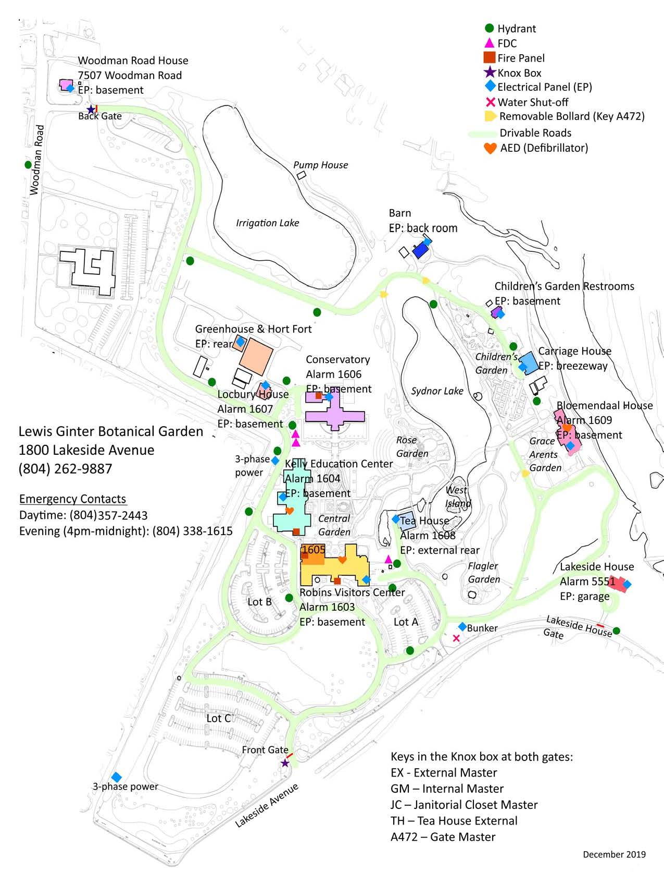

Appendix 4: LGNR Irrigation Map

Appendix 5: LGBG Network Diagram

Appendix 6: LGBG Physical and Virtual Server List

PC Name | IP Address | Purpose
Physical Servers
LGBGDPM01 | ###.###.### | Backup server and storage
LGBGFS01 (decommissioned) |  | WSUS Server shortly
LGBG-VM01 |  | Virtual Server Host
LGBGVM02 |  | Virtual Server Host
LGBG-VM03 |  | Virtual Server Host
LGBG-VM04 |  | Virtual Server Host
LGBg-VM5 |  | Virtual Server Host
LGBG-DC1 |  | Active Directory - Domain Controller group policies, users accounts card catalogue of users
LGBGAD02 |  | Secondary Domain Controller, located in Bloemendaal House
LGBG-Files |  | File Share (S,P,L,U)
LGBG-WAPC |  | Unifi Controller for WAPS
LGBG-MIP02 |  | MIP Accounting software / Abilia
LGBG-IRIS01 |  | IrisBG Plant Records Database
LGBG-DMS |  | Dell Management Server
LGBG-HELPDESK |  | Service Desk Ticketing Software
LGBG-PDQ |  | PDQ deploy and inventory software
LGBGRDS02 |  | Remote Desktop Server
Plants Plus |  | Windows 7 PC for PlantsPlus
LGBGREAP01 |  | Raiser's Edge Database
LGBGREWB02 |  | Raiser's Edge Web
LGBGtoro |  | Toro Irrigation software
LGBG-Print |  | Print server
LGBG-Sandbox |  | Sandbox for helpdesk & software testing
LGBGTAM02 |  | TAM Point of Sale

Appendix 7: Living Collections Contractors/Vendors

LEWIS GINTER BOTANICAL GARDEN  1800 Lakeside Ave., Richmond VA 23228  SMALL TREE WORK:  Ryan Olsen, Hort. |  Steve Reardon, ISA |  Avery Crain, Gardener |  LARGE TREE WORK:  Davey Tree | 804.288.2602 (office)  Alec Selz, Sales Arborist  | alec.selz@davey.com  GROUNDS/TURF:  Ruppert Landscaping | 804.229.3189  Michael Lyne, Field Manager  HVAC:  James River Air | 804.358.9333  Anthony, Mechanic | 804.624.7587  GLASS HOUSE REPAIRS:  Rough Brothers | 513.242.0310 (main)  Ryan Dempsey, Account Manager  513.618.7246 (office)  (cell)  NURSERY SUPPLIES:  Griffin Greenhouse | 862.233.3454  5612 Pride Rd., Richmond, VA 23224  IRRIGATION REPAIRS:  Montgomery Irrigation | 804.303.2004  IRRIGATION LAKE PUMP:  Pro Pump & Controls | 502.633.0677  WATER:  Henrico Co. Utilities | 804.501.4275  WATER DELIVERY:  Water King, Inc. | 862.236.3555  SNOW-PLOWING:  BWS Landscaping | 804.204.1568 | LEWIS GINTER NATURE RESERVE  18168 Dogwood Trail, Rockville, VA 23146  LARGE TREE WORK:  Mountain Road Tree Service and Landscaping | 804.475.9216  15431 Mountain Rd., Montpelier, VA  HEAT PUMP/MECH:  Barksdale Mech. | 804.690.3484  PO Box 386, Montpelier, VA  WELL WORK:  Royall Pump & Well Co, Inc.  Joshua Hogston, Manager  804.598.8147  WATER:  Goochland Co. Dept. of Public Utilities | 804.556.5835  804.556.5349 (weekend, after hours)  WATER DELIVERY:  Water King, Inc. | 862.236.3555  SNOW-PLOWING:  BWS Landscaping | 804.204.1568

Appendix 8: Living Collections Post-Disaster Resources

Karen Clowers, Manager of Volunteers
Phone
Email

CVNLA (Central Virginia Nursery and Landscape Association)
Phone
Email

Virginia Native Plant Society, State Contact
Phone
Email

Azalea Society of America, Northern Virginia Chapter
Phone
Email

LEWIS GINTER BOTANICAL GARDEN  1800 Lakeside Ave., Richmond VA 23228  Extension Master Gardeners and/or Virginia Cooperative Extension  City of Richmond  Main Office: 804.786.4150 | LEWIS GINTER NATURE RESERVE  18168 Dogwood Trail Road, Rockville, VA 23146  Extension Master Gardeners and/or Virginia Cooperative Extension  Goochland County  Main Office: 804.556.5841

Appendix 9: Non-Living Collections Contractors/Vendors

There is an emergency salvage supply kit located in the Lora M. Robins Library librarian’s office, containing hard hats, newsprint, freezer paper, tarps, flashlights, tape, rubber gloves, extension cords, nylon line, etc.
FREEZER FACILITIES:  Radford Cold Storage | 804.644.2671  4808 Radford Ave., Richmond, VA  www.richmondcold.com  FREEZER FACILITIES:  Lineage Logistics | 804.232.1266  2900 Cofer Rd., Richmond, VA  REFRIGERATED TRUCKS:  Mid-Atlantic Transportation Refrigeration| 804.798.2040  11073 Washington H., Glen Allen, VA  STORAGE CONTAINERS:  Commonwealth Trailer | 804.798.1099  711 North Washington Highway  Ashland, VA 23005  855.933.1718  STORAGE CONTAINERS:  SmartBox | 804.282.9944  2100 Dabney Road, Richmond, VA  877.627.8269  CRATES & BOXES:  Lowe’s | 804.219.0640  1640 West Broad St., Richmond, VA  Home Depot | 804.289.6020  6501 West Broad St., Richmond, VA | ELECTRIC FANS & PUMPS:  Rental Works | 804.288.0018  6520 W. Broad Street, Richmond, VA  Sunbelt Rentals | 804.364.3026  Branch #166  12570 Broad Street, Richmond, VA  DEHUMIDIFIERS & GENERATORS:  Rental Works | 804.288.0018  6520 W. Broad Street, Richmond, VA  Sunbelt Rentals | 804.364.3026  Branch #166  12570 Broad Street, Richmond, VA  800.667.9328  PORTABLE HVAC:  Sunbelt Rentals | 804.364.3026  800.667.9328  DOLLIES & PALLETS:  Interstate Pallet | 804.226.0229  3707 Nine Mile Rd., Richmond, VA  Recycled Pallets | 804.730.4218  8029 Industrial Park Rd., Mechanicsville, VA 23116

Appendix 10: Non-Living Collections Post-Disaster Resources

The following are selected conservators from the Richmond and Virginia area, who may serve as initial contacts in an emergency or disaster scenario. An asterisk (*) indicates the named disaster response volunteer is a member of the Virginia Conservation Association. Many conservators in private practice work from their home or have made their home telephone numbers available for this list. These contact numbers are to be used by Garden staff only in the event of a disaster that affects Non-Living Collections. These numbers are NOT to be publicly distributed.

ARCHITECTURAL MATERIALS:  Name  Address  Phone number(s)  Name  Address  Phone number(s)  BOOKS AND PAPER:  Name  Address  Phone number(s)  Name  Address  Phone number(s) | COSTUME/TEXTILES:  Name  Address  Phone number(s)  FURNITURE:  Name  Address  Phone number(s)  PAINTINGS & FRAMES:  Name  Address  Phone number(s) | PHOTOGRAPHIC MATERIALS:  Name  Address  Phone number(s)  METALS, SCULPTURE:  Name  Address  Phone number(s)
Additional information is available from the American Institute for Conservation (AIC) at (202) 452-95

Appendix 11: Facilities Contractors/Vendors

ALARM SYSTEM MONITORING:  Fire & Life Safety America (FLSA)  800.560.9425 | 804.222.1381  Kenneth, Technician  804.497.1102  SECURITY & FIRE ALARM SYSTEM EQUIPMENT & REPAIR:  BFPE | 804.447.2900  KITCHEN FIRE SUPPRESSION:  Safety First | 804.232.2958  BUILDING AUTOMATION:  Mid-Atlantic Controls | 804.262.4923  Matt Wells, Technician  804.426.0176 (cell) | 804.502.0871  ELECTRICITY:  Dominion/VA Power | 888.667.3000  ELECTRICAL:  Abbott and Harris | 804.363.3241  Chewning & Wilmer | 804.231.7373 (24-hour emergency)  GENERATORS:  Carter Machinery | 804.837.4966  804.814.1558 (after hours service)  HVAC PM/SERVICE (Primary):  James River Air | 804.358.9333  Wade, Service Tech. | 804.393.3702  NATURAL GAS:  City of Richmond Dept. of Public Utilities | 804.646.4646  PROPANE:  Quarles | 877.444.3835 (main)  804.355.7104 (local office) | PLUMBING (Primary):  James River Air | 804.358.9333  Wade, Service Tech. | 804.393.3702  PHONE:  Pritchett Comm. | 804.264.7888  Willie | 804.855.4457  PHONE SERVICE:  Verizon | 800.837.4966  Account #556-674-669-0001-68  ELEVATOR MAINTENANCE:  Thyssen-Krupp | 804.355.9792  800.492.3285 (24-hour emergency)  RUG CLEANING:  B&L Flooring |804.405.3808  ROOFING:  Davidson Roofing | 804.357.0086  NW Martin & Co. | 804.648.2811  Cross Timbers Roofing | 804.441.1773  R.W. Harper & Co. | 804.233.6550  Saunders Roofing | 804.353.9919  SNOW-PLOWING:  BWS Landscaping | 804.204.1568  WATER/SEWER:  Henrico Co. Utilities | 804.501.4275  WATER PLAY:  Southern Playground | 757.943.1225  WELDING:  West End Machine | 804.266.9631

Appendix 12: IT Contractors/Vendors

Responsibility for the healthy and maintenance of the Garden’s network rests with Strategy Café (information below). This vendor can also provide assistance during disaster recovery and additional technical support for urgent and high-level issues.
PRIMARY CONTACT:
Name
Address
Phone number(s)

MFD, LASER PRINTERS:
Name
Address
Phone number(s)

Appendix 13: Disaster Impact Report

- In the case of a disaster or incident, in accordance with the LGBG Disaster Plan, the DoF, DoH or designee, will serve as Incident Commander (IC).
- The IC is to participate in, delegate and/or assign property-wide damage assessments.
- The IC should complete this form and submit it, along with any additional information or photographs, to the COO as soon after the disaster or indecent as is safe and practicable.
- This form is a tool that should be used to report damages to the COO, leadership, insurance, and other stakeholders. It will also serve to inform disaster plan reviews and improvements.

Mark the type of incident or disaster you are reporting on this form:
- High Winds | - Impoundment Failure | - Loss of Rare Plants
- Tornado | - Fire | - Bomb/Bomb Threat
- Severe Thunderstorm | - Ice Storm | - IT Compromise
- Drought | - Snow Storm | - Other:
- Loss of Irrigation | - Climate Control Failure | - Other:

After completion of this form, attach all additional documents or photographs, and submit to COO, with a curtesy copy to FC. Fill in the following when submission is complete.
- Submitted to COO, cc: FC, by ________________ (name) on ___________ (date/time)

List mitigating actions taken before the disaster:

List damages that are of primary concern to: staff and guest safety, are of the highest level of salvage priority, or are otherwise of paramount concern:

Note salvage or clean-up priorities and/or schedules:

List losses to Living or Non-Living Collections, Facilities, or IT, esp. losses or damages to items noted as identified assets (Section V.).

Lessons learned: note anything that could be improved in the disaster response, i.e. communication improvement, tools or resources that would have been useful in that situation, issues with contact information, concerns about staff availability, etc.

Appendix 14: Bomb Threat Procedures and Checklist
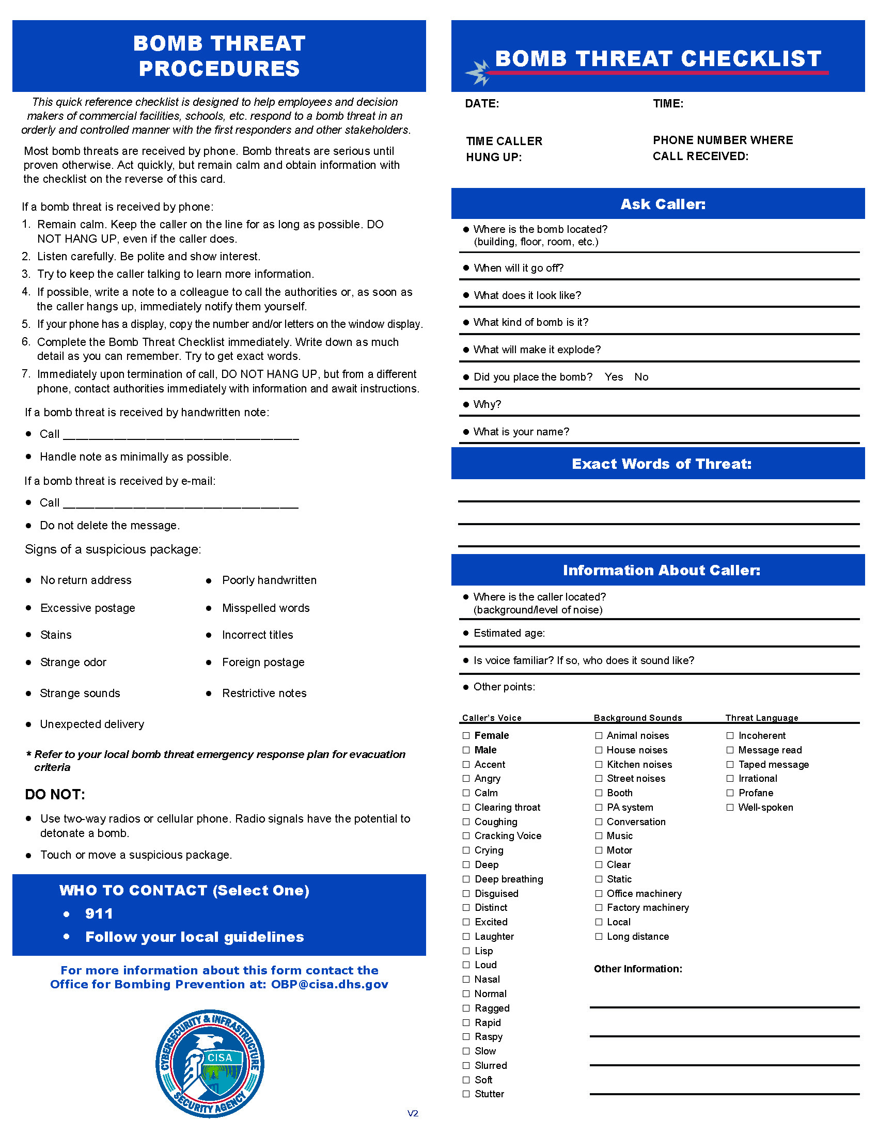

Appendix 15: Active Shooter Pocket Card

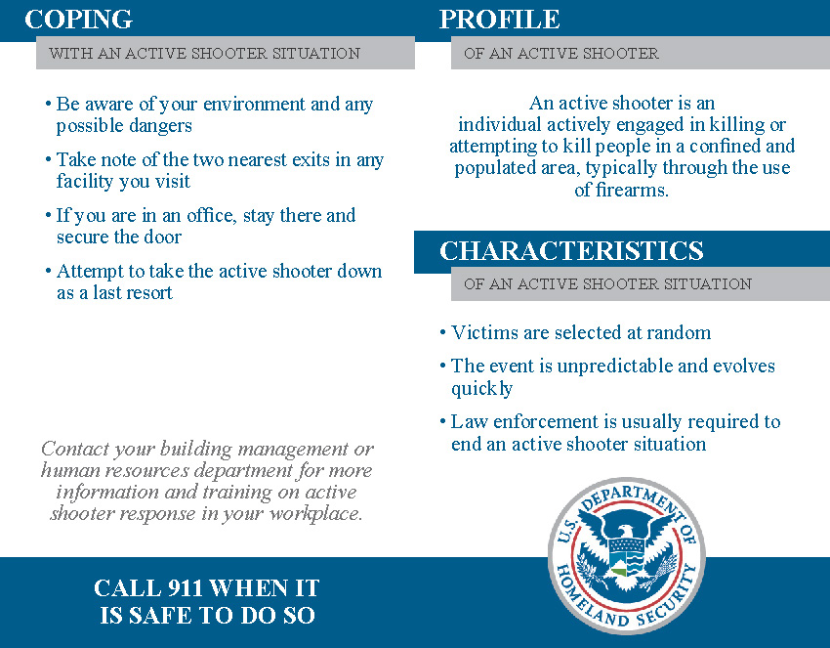

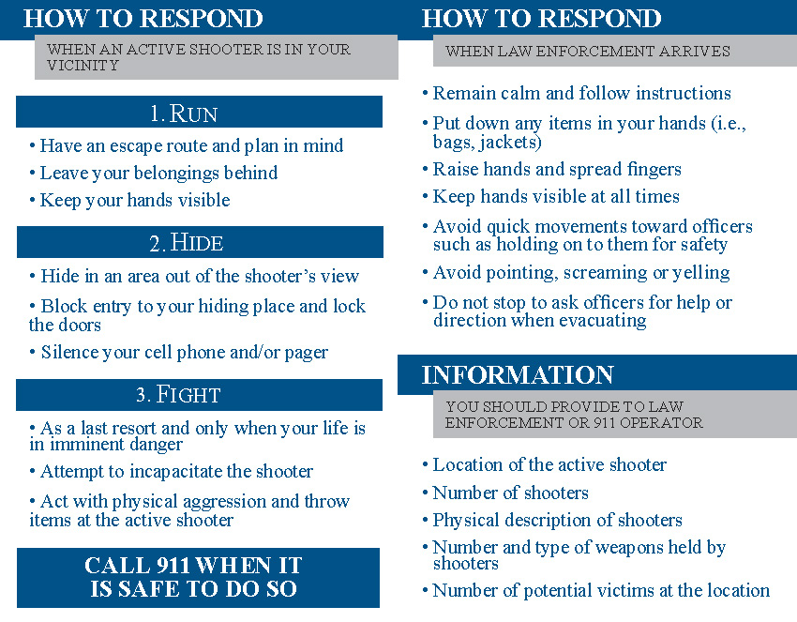

THIS PAGE
INTENTIONALLY LEFT BLANK

LEWIS GINTER BOTANICAL GARDEN
DISASTER PLAN

Approved September 28, 2021

