Process Documentation for Creating Accessions in IrisBG
Purpose: To train current and future employees in the process of creating accessions in IrisBG, specifically as it pertains to tree inspections. Cincinnati Zoo and Botanical Garden was founded in 1873. While there are extensive records, there are inevitably some items that have not been adequately recorded, whether through lost or damaged records, unrecorded planting, or naturally generated plant material.
Accessions are essential for documenting tree risk reports and tree management practices such as pruning, cabling, and pest treatments. In cases where we have no known accession information for a tree that needs documentation, a new accession shall be created to allow a record of trees through time to be created.
There are employees at the CZBG and former employees who may have institutional knowledge of plantings. In most cases it is not practical to wait for this knowledge before we create an accession, and it is reasonable to create a new accession with the opportunity to find clarity in the future.
IrisBG: “IrisBG is a modern and efficient professional software and database solution for botanical collections. The system is a complete solution and is used by botanical gardens, arboreta and large estates around the world.” https://www.irisbg.com/about-p.aspx
We are using IrisBG to store our tree management history. It is where we currently store accessions information, and the program has features that allow us to document work history.
Creating a New Accession and Item
Each individual specimen will have a unique Accession Number and be the sole Item for each accession. The purpose of creating new accessions for existing plant material is a lack of planting knowledge, and creating a unique Accession Number for each unknown tree allows for the most flexibility and clarity about these trees going forward.
- Open IrisBG
- Navigate to Collections>Accessions
- Click “Clear/New” at the top to navigate to a blank new accession screen.
- Under the “Details” tab of the Accessions screen:
- Enter “0000” in the “Acc. year" field (we are using “0000” as a placeholder that is neutral as regards any speculation on the possible year the tree was planted or came up from seed).
- Next, navigate to the “Taxon Name” field and begin typing the plant name. Select the genus and species from the drop-down menu.

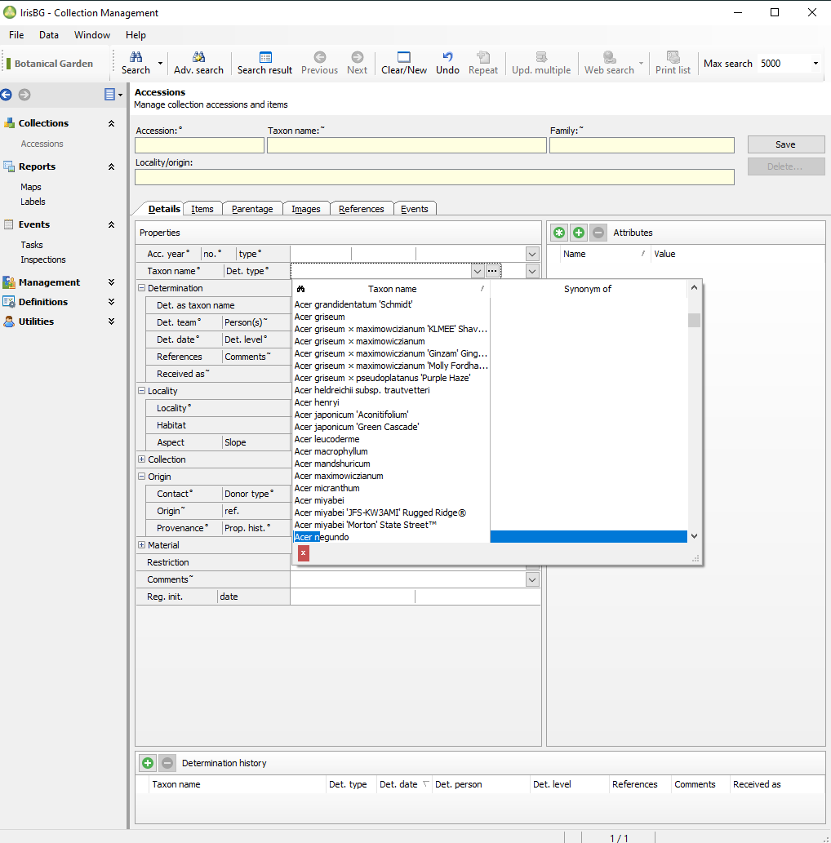
Under details tab:
- Go to Origin>Contact and select the appropriate option. In almost every case one will select “0157 - Unknown”.
- Next go to Origin>Provenance. Select the appropriate option. In almost every case one will select “Unrecorded”.
- Next go to Material>Type. Select Plant(plant), unless there is evidence to suggest another option (a cage or webbing to indicate B&B, for example)
- Next go to Material> No. spec. and enter the number “1” (necessary for reports later on)
At this stage, click “Save” in the top right of the screen. This will auto-populate many fields and generate an accession year and number, collectively referred to by many as the Accession Number.
Navigate to the “Items” tab within the new Accession Number.

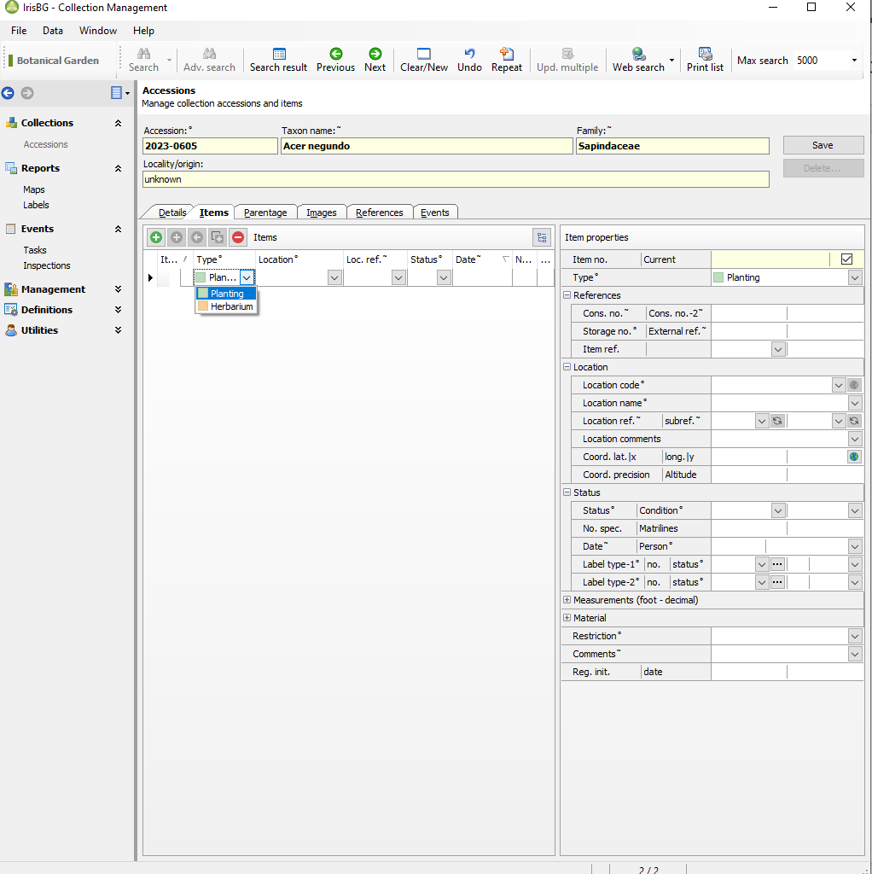
On the left side, select the drop down menu under “Type” and select “Planting”.
Next, on the right side make a reasonable effort to input the Location Code and Location Name. If this cannot be determined, select “Unknown”. Correct as soon as possible by asking the plant records coordinator for any needed information.
Enter the GPS data. This can be input/placed with coordinates if known. Alternatively, click on the “Show Location In Map” globe icon and select the location on the map. This is a critical step in managing trees through time and must be accomplished when using this method of accession creation.

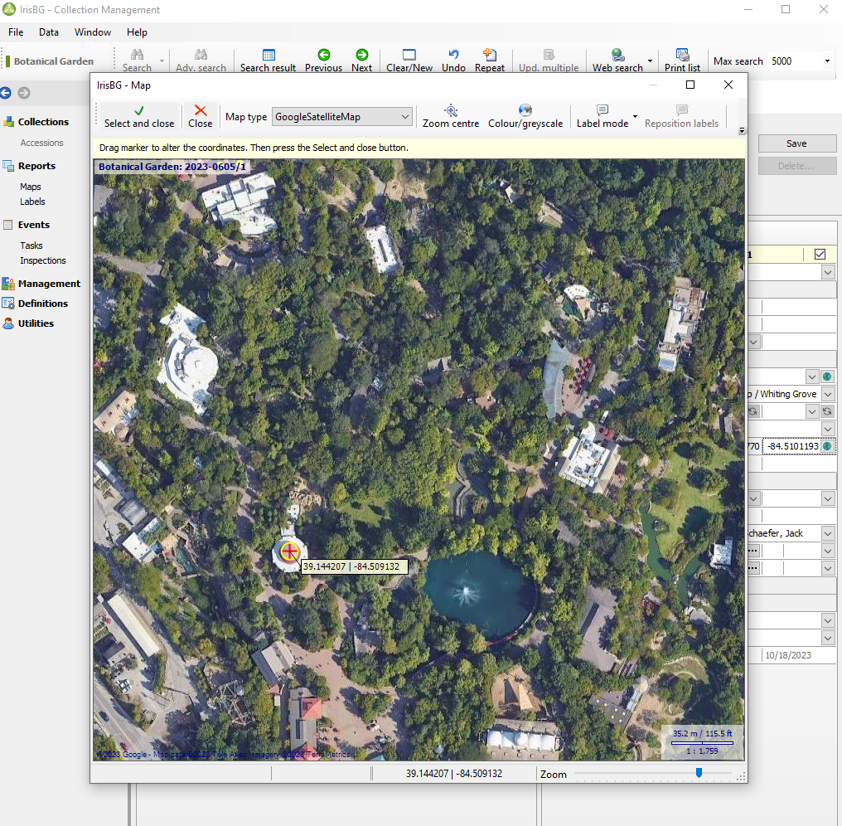
Under Item Properties>Status>No. spec. (Number specified) input “1”. All trees accessioned in this manner will be the singular item for each Accession Number.

Click “Save” in the top right corner.

